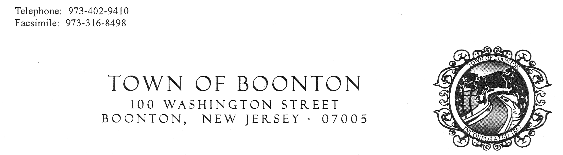

RESOLUTION 14-179
RESOLUTION OF THE MAYOR AND BOARD OF ALDERMEN OF THE TOWN OF BOONTON AUTHORIZING EXECUTION OF A COLLECTIVE BARGAINING AGREEMENT BETWEEN THE TOWN OF BOONTON AND THE BOONTON ASSOCIATION OF STREET AND WATER EMPLOYEES

WHEREAS, the current collective bargaining agreement (contract) between the Town of Boonton and the Boonton Association of Street and Water Employees expired on December 31, 2013; and

WHEREAS, the Town’s negotiating committee and the Boonton Association of Street and Water Employees have successfully negotiated the terms and conditions for a new three-year contract, the term of which shall be from January 1, 2014 through December 31, 2016;

NOW, THEREFORE, BE IT RESOLVED by the Mayor and Board of Aldermen of the Town of Boonton, New Jersey, that the terms for the renewal of the Boonton Association of Street and Water Employees contract as negotiated and agreed upon by the committee and the Boonton Association of Street and Water Employees be and is hereby approved; and that the Mayor and Clerk be and are hereby authorized to execute a contract with the Boonton Association of the Street and Water Employees incorporate said terms on the Town’s behalf.

I, Cynthia A. Oravits, Municipal Clerk of the Town of Boonton, hereby certifies the foregoing Resolution to be a true and correct copy adopted by the Mayor and Board of Aldermen at a regular meeting of said governing body held on September 2, 2014.

____________________________
Cynthia A. Oravits, Town Clerk

